Chapter 10, Problem 63.

Obtain the Norton equivalent of the circuit depicted in Fig. 10.106 at terminals
a-b.

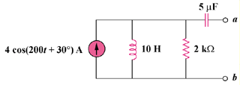

Figure 10.106
For Prob. 10.63.

